Start Ubuntu and run the following:
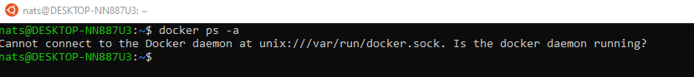

https://www.youtube.com/watch?v=LQjaJINkQXY
DockerFile creation steps:
- Create a file named Dockerfile ( sudo touch Dockerfile)
- Add instructions in Dockerfile ( vim Dockerfile & press i) -> FROM ubuntu
MAINTAINER Natraj
RUN apt-get update
CMD [“echo”, “Hello, First Docker Image”]
3) Bild Dockerfile to create image ( sudo docker build . )

Sudo docker build -t myimage-1

Sudo docker images

4) Run image to create container :
Sudo docker run myimage-1

